Whakatāne District Recovery team’s relationships with multiple agencies
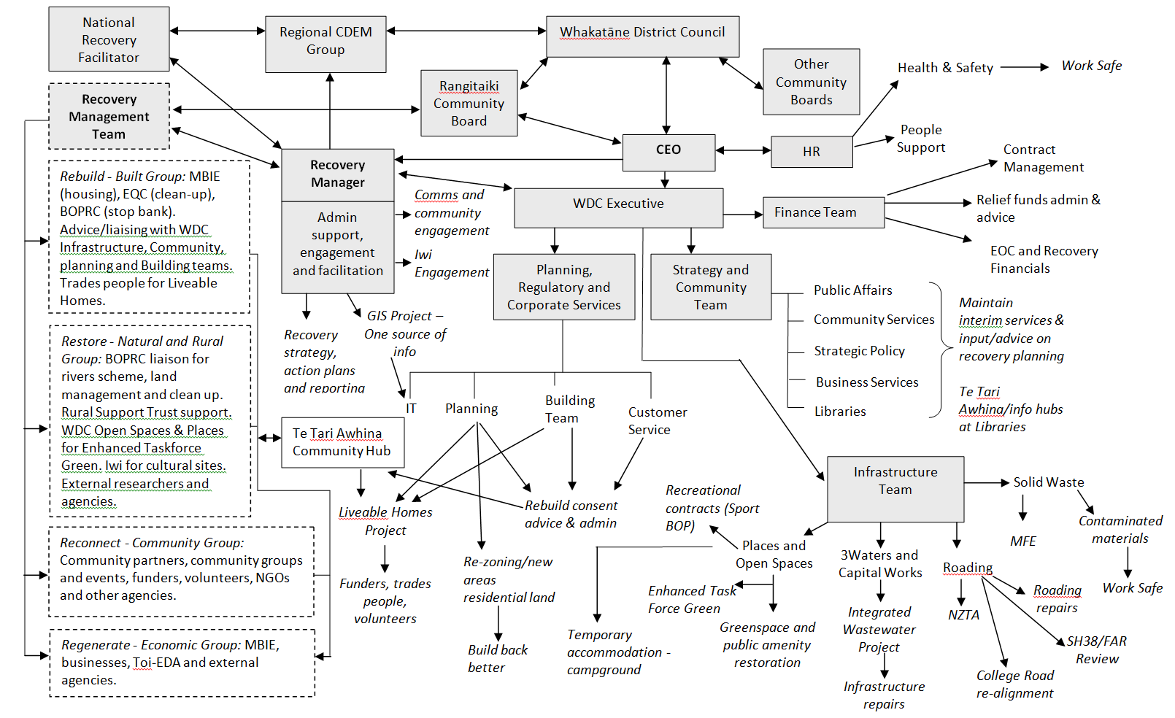
(adapted from Waimakiriri District Council)

