Watch your Waste

PLEASE Keep Our Streets Clean
- Keep rubbish off the streets and roadsides  - No Dumping  - Request skip bins for larger loads  - Take small loads to Mall Car Park waste yard  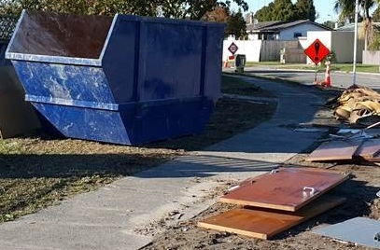 | 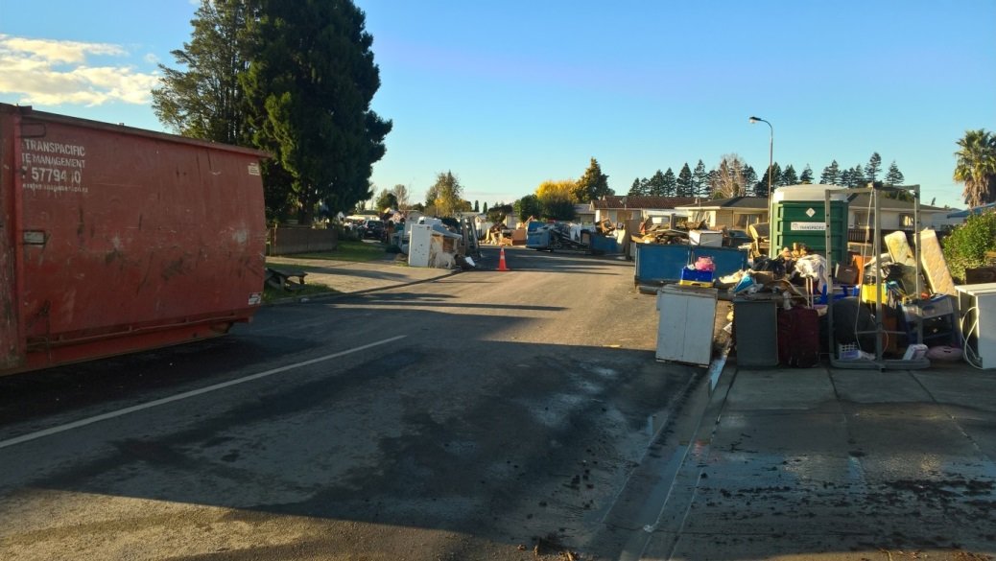  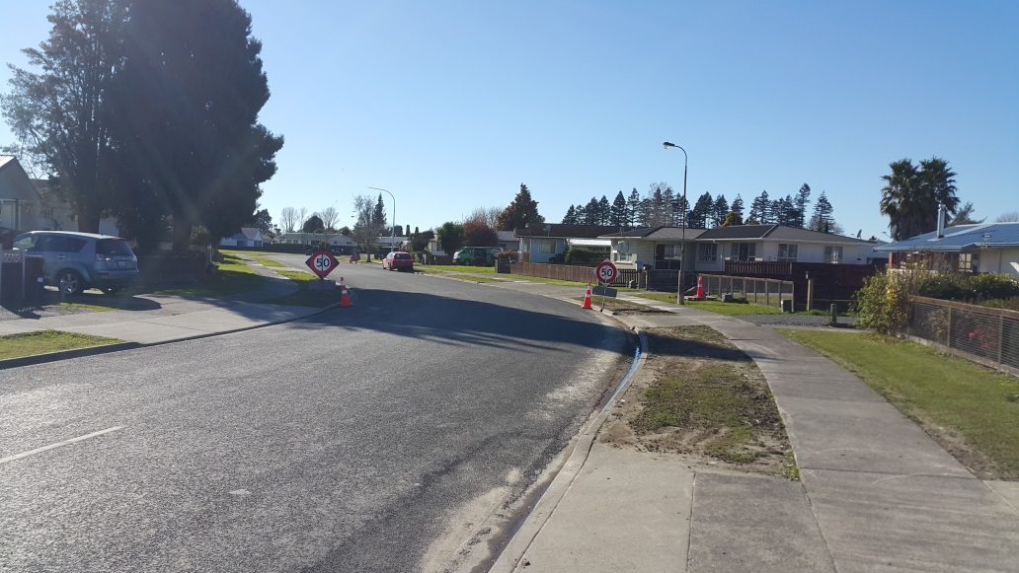

Skip Bins
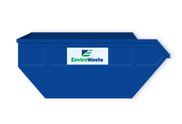 | - Available to end of June (at least)  - Are for house contents, garden and shed wastes, materials from the strip-out of properties (wall linings, floors etc.)  - Contractors rebuilding need to manage their own waste and skip bins

Rats
- 70 bait and trap stations inside the red stickered area
- Monitored twice weekly
- 40 rats removed in the last two weeks

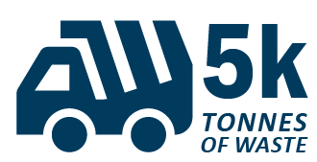  Over 5,300 tonnes of waste (including silt) sent to landfill from Edgecumbe alone. This is equivalent to 6 months of waste from the whole of the Whakatāne District. | [INFOGRAPHIC]  968 skips bins emptied (this does not include large bins and trucks loaded on the streets) | Over 2,200 tonnes of silt removed and sent to landfill | 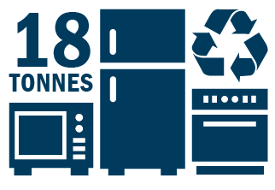  Over 18 tonnes of whiteware and steel recycled | [INFOGRAPHIC]  Over 5 tonnes of hazardous substances collected and disposed of appropriately

