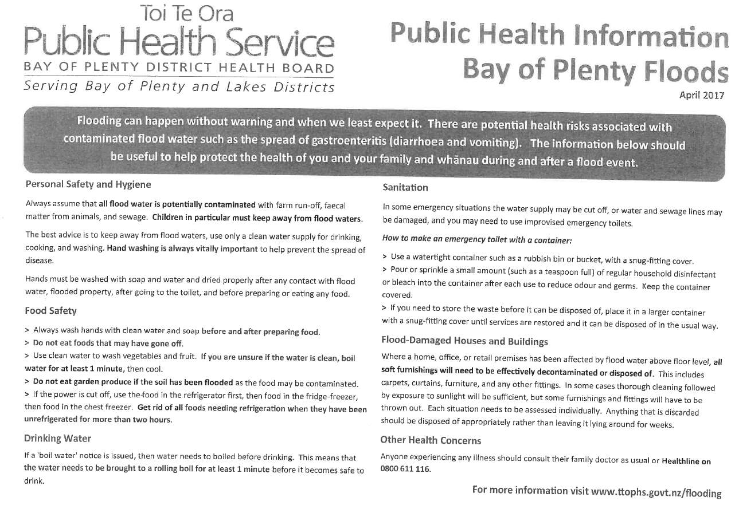

**NOTE: The above has been updated.**

**Please go to** [**https://www.ttophs.govt.nz/flooding**](https://www.ttophs.govt.nz/flooding)