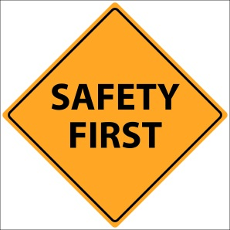 | School Safety  Edgecumbe

Road Safe

PLEASE Stay Off the Stopbank

PLEASE use the new footpath along College Road

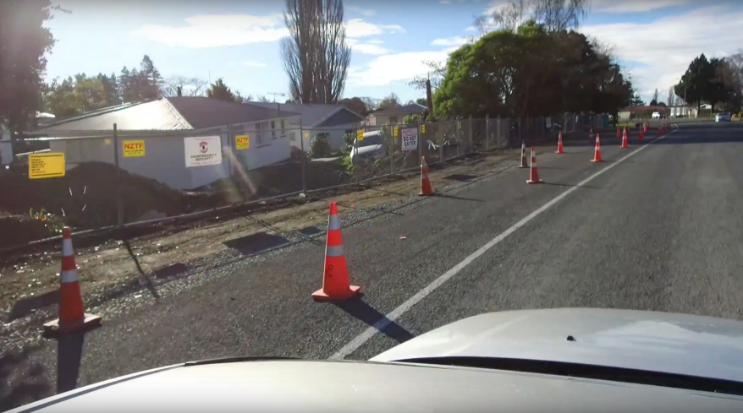

Student Safety Packs provided (containing a selection of the following):

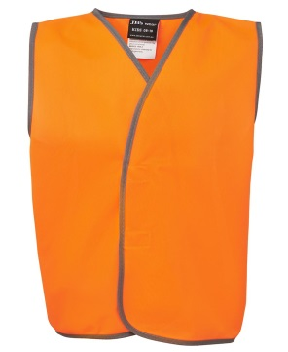 | - High Visibility Vest  - Torch  - Pens / Pencils  - Whistles  - School Books  - Travelwise School information sheet  - Competition for $20 Pressie Card
Water Safe
Water tested (township & Schools) - no drinking water issues

