REMOVAL OF SILT AND DEBRIS
The recent flooding in Edgecumbe has resulted in some houses in the area being inundated by silt and debris. As part of the wider recovery clean-up, EQC will be in your area during May and June clearing the worst of the silt inundation from land around affected properties.
Here is some information to help you better understand what work EQC may be undertaking at your property.

Most of the silt inundation is less than 15mm and will disappear on its own
Generally, in open areas where the build-up of silt is quite minimal (less than 15mm deep), it is expected that the grass will grow through relatively quickly and we won’t need to remove it. This will gradually disappear in the weeks following the floods, and the effects of sun, wind and rain will also assist.
The silt is essentially the soils and sands of the heavily scoured properties of Edgecumbe which have been swept up and deposited on your land by the velocity of the water. Contaminant levels (as advised by Whakatane District Council) are low but basic hygiene practices should be followed. For further details or if you have any health and safety concerns, please contact the Whakatane District Council on 0800 306 0500.

Silt inundation over 15mm will need to be removed
- Lawns and gardens - we will remove silt build-up that is over 15mm in depth and any debris from lawns, gardens and other similar areas.
- Artificial surfaces – we will remove all silt and debris from artificial surfaces because it will not absorb on its own.

Silt inundation that has settled under houses will be removed in some cases
- We will remove silt from underneath houses where it has affected the use of the land under your house. As a general rule, we will remove silt from underneath houses if it is greater than 15mm. In some cases it may be appropriate to spread small but thicker piles of silt out so it becomes a covering of less than 15mm rather than the need to remove it.
- We will clear all silt and debris on polythene or similar materials in the subfloor, unless the amount is so insignificant that it is not likely to cause any issues.
For further information about the work EQC is doing in the Edgecumbe area, please contact EQC on 0800 326 243 or by email: info@eqc.govt.nz
FOR MORE INFO VISIT WWW.EQC.GOVT.NZ/CLAIMS OR CALL 0800 DAMAGE (326 243)
On the next page, we have provided pictures as examples of what different levels of silt could look like, and whether or not we will be clearing these properties.

The below photos show different levels of silt inundation on land that EQC may or may not remove
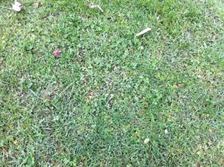 | 0mm | Requires no reinstatement
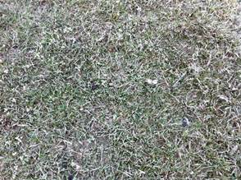 | <5mm |  | Common Damage under houses
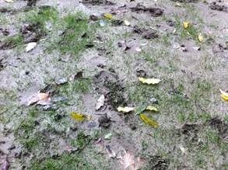 | 10mm |  |  | Common damage
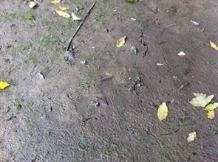 | >15mm  20mm | Inundation removal |  | around houses
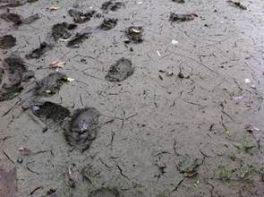 | 50mm
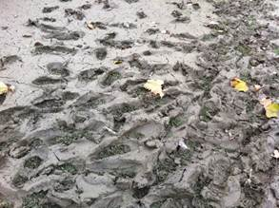 | 100mm
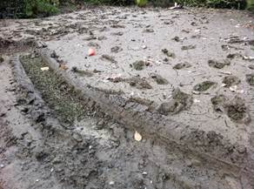 | 200mm

