Red Stickered Properties
Access ID Cards Process

Contents
1. Red Stickered Access ID Cards Process 3
2. Process Detail 4
2.1. Rules of Access 4
2.2. Assisted Entry Team 4
2.3. Allocation of ID Cards 4
2.4. Notification to Security Firm 4

Red Stickered Access ID Cards Process
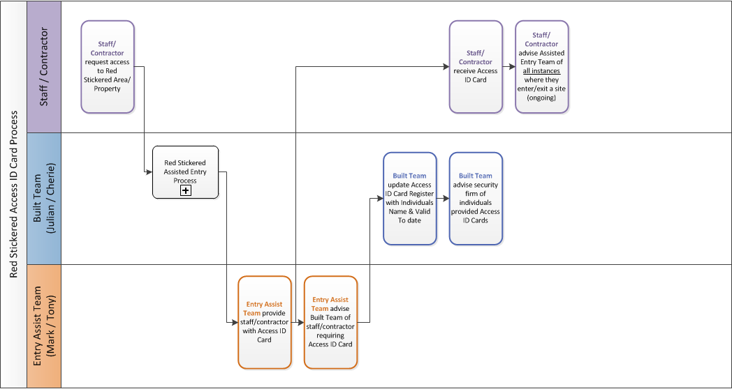

Process Detail
The purpose of the Access ID Cards is to allow authorised staff and contractors access to Red Stickered Properties without the need to be accompanied onto site for each entry.

Rules of Access
Access ID cards will only be supplied to staff and contractors who:
- Have been assisted onto site by one of the Assisted Entry Team previously
- Have undergone a full Health & Safety Briefing with one of the Assisted Entry Team
- Have a legitimate work purpose for being within a Red Stickered property/area
Individuals allocated Access ID Cards MUST for safety reasons:
- Enter properties in pairs.
- Advise a member of the Assisted Entry Team each time they enter a Red Stickered area for work and when they leave.

Assisted Entry Team
  - Mark Cleghorn (WDC) mark.cleghorn@whakatane.govt.nz 027 807 0723
  - Tony Gillard (Rural Fire Manager) tony.gillard@whakatane.govt.nz 027 280 9497

Allocation of ID Cards
The Assisted Entry Team will advise of staff/contractors who are now authorised to go into Red Stickered Properties/areas who require Access ID Cards and the date until this authorisation is valid.

Notification to Security Firm
The Built Team will advise the current Red Sticker area Security Firm of the names of all staff/contractors who have been allocated an Access ID card.

