Whakatāne District Navigation Service

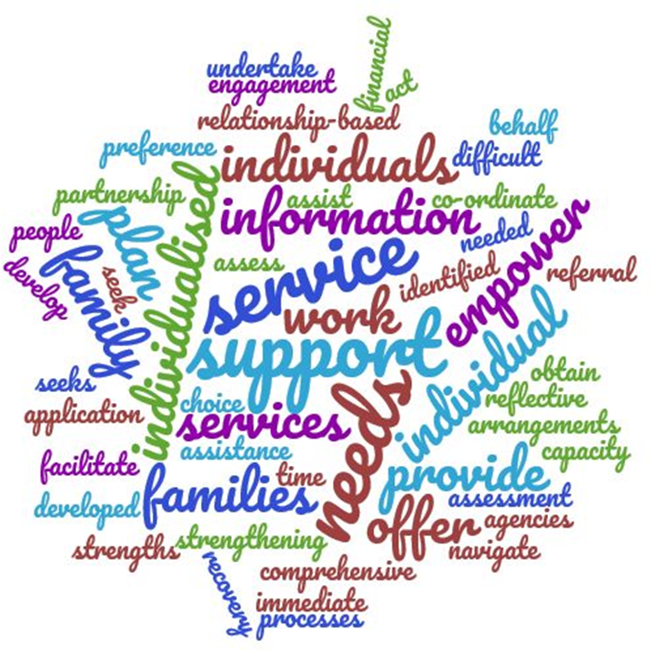

July 2017

Contents
Introduction 4
Objectives of Whakatane District Navigation Service 4
Structure 5
Team Functioning 5
Policies 8
Health, Safety and Security 8
Procedures 11
Referral process 11
Supporting Documentation 14
Service Quality 15
Privacy & Consent 15
Feedback and Complaints 15
Service Guidance and supporting information 16
Closing Recovery Plan where someone has on-going intensive support needs 17

The team wish to acknowledge the work of the Canterbury Earthquake Temporary Accommodation Service (CETAS) and thank them for generously sharing documentation which has formed the base for this document and other forms developed.

Introduction

The Whakatāne District Navigation Service (WDNS) helps individuals/family/whānau recover from the effects of Ex-Cyclone Debbie and Cook by connecting them to the information and resources they need.
Ex-Cyclone Debbie and Cook resulted in significant regional flooding, a stop bank breach at Edgecumbe, slips causing road closures and isolation for communities at Ruatāhuna, Te Mahoe, Ruātoki, and Te Whāiti. Services including power, water and wastewater were disrupted.
The degree and severity of this event resulted in significant property damage (most people won’t be back in their homes for many months), a breakdown in community infrastructure, disruption to essential services and the de-stabilisation of the physical and emotional condition of people.
The WDNS is a partnership between the Whakatāne District Council, the BoP DHB, MSD and Te Rūnanga o Ngāti Awa. The Whakatāne District Council is the employer and administering authority

Objectives of Whakatāne District Navigation Service

The Navigation service is an outreach service providing an essential element in assisting flood affected people through the challenges (family, financial, housing & emotional wellbeing) they face through the provision of wrap around services.
The Navigator supports the recovery of affected individuals / family / whānau by:
- providing an individualised, relationship-based service that supports and empowers families / individuals, strengthening their capacity over time
- providing an individualised service based on a comprehensive needs assessment, which is used to develop a recovery plan, in partnership with the individual or family. The plan is reflective of their choices and preferences for the service arrangements being developed
- brokering and co-ordinating with agencies peoples easy access to information and the services they need particularly assisting those individuals/families finding it difficult to navigate the system of support available to them for themselves

Structure

Team Functioning
Reporting lines/ relationships
The employer is the Whakatāne District Council.
Navigators report to the Team Leader. The Team Leader has responsibility for the day to day operations and oversight of the service activity, navigator caseload, monitoring trends and escalating issues.
Meetings
Navigators meet regularly with the Team Leader, to share information and receive advice/support regarding individual cases.
Navigators meet as a collective for training purposes, information sharing, discussion on service issues and development/implementation of shared best practice.
The following meetings will support the efficient management of the Navigation Service:
Weekly:
Team meeting to cover the following:
- Health and Safety
- Training opportunities
- Allocation
- Review of caseloads and effectiveness
Weekly:
One on one meeting with Navigator and Team Leader
Monthly:
Collation and reporting of statistics for the Oversite Committee.

.
Training
An induction programme will be developed including training in the relevant systems and polices used by the WDC e.g. home visit policy, Health & Safety practice.
The Coordinator will identify and provide training relevant to the Navigator role ensuring consistency of information and practice.

Roles and responsibilities
Organisation | Role | Responsibilities
Oversight Committee | Oversight of Navigation team | - Governance Body.  - Made up of one representative from the Whakatāne District Council, Bay of Plenty District Health Board, Te Rūnanga o Ngāti Awa and Ministry of Social Development.  - These agencies and representatives have a vested interest and role in community recovery.  - The frequency of meeting is likely to be fortnightly initially.  - Provides direction.
Whakatāne District Council | Line Management accountabilities | - The employer.  - Ensures employer service standards are understood and adhered to such as: H & S incident reporting, information management, supervision and management of performance issues.
Team Leader | Service coordination and workload management | - Monitor and report on performance and practice.  - Case load allocation and oversight.  - Develop, implement and maintain navigator best practice.  - Train and support navigators.  - Develop and maintain key relationships with agencies/organisations providing assistance to impacted residents (eg insurance, council, EQC, MSD, MBIE, RST Navigator programme etc).  - Ensure adherence to staff health and safety practice.  - Communicate and engage with key stakeholders - implementing a range of proactive strategies that promote and encourage use of the service.  - Convene regular navigator meetings, ensuring they have information and access to resources, information and points of contact on what is available.
Navigator(s) |  | - Wrap around co-ordination and support, providing one point of contact for case load.  - Provide basic psychological first aid eg. practical and emotional short-term support to reduce distress.  - Case management and reporting.  - Comprehensive assessment and identification of what support/services are required.  - Advice/information and linkages to facilitate easy access to identified support services.  - Work collaboratively with community partners to identify needs and ensure a comprehensive and equitable service is provided.

Policies

The Navigation Service is a service provided by the Whakatāne District Council and people engaged to deliver the service are employed by the Council. Employees are therefore required to adhere to staff health and safety practice and WDC employment policies and codes.

Health, Safety and Security

The health, safety and security of staff is paramount. Staff are not expected to put themselves into situations of risk.
There may be situations where it may be desirable for two staff to attend home visits.
Staff should get direction from the Team Leader when they are unsure of situations, ahead of home visits taking place. It may be preferable for some people to only be seen in the office or at a community locality where others are nearby. The following steps guide good practice to help ensure staff safety for when you are preparing to visit people in their home.
House visits
House visits
Stage | Steps
Basic safety precautions | - Be familiar with health, safety and security practice.  - Discuss as a collective potential situations and scenarios that may occur and how best to deal with them.
Staff responsibilities | - Take personal responsibility and never put yourself at risk.  - Have a plan in place for calling the Team Leader, other staff and/or the police for assistance, for example: carry a cell phone that is pre-programmed with a short dial code for the police and the office.  - Report all incidences to the Team Leader.  - Ensure that your Team Leader is aware of expected and actual return or if you change the time of your return.  - Record the details of planned visits in the central logbook.  - Leave clear information about times, dates and address(es) where interview(s) will occur.  - Do a summary check in the database to see if the client has any history of difficult behaviour.  - Be aware of cultural differences when dealing with clients.  - Ensure that if you are returning straight home and not calling into the office you advise the Team Leader accordingly.  - Remember your Team Leader needs to know that you have returned safely after visits away from the office.  - If you don't return when you say you will the Team Leader will try to contact you. If this is not successful they will put in place plans to trace you.  - Report any incidents to the Team Leader - make a full file note of the actions and statements that occurred.
Safety precautions | - Call the client first and make sure they are comfortable with arrangements.  - Check your vehicle before you leave, making sure you have sufficient petrol and are familiar with the area you are visiting.  - Remember to carry your driver's licence.  - Know the location of the nearest police station.  - Park the vehicle on the roadside, not in the driveway. Have it parked in such a way that it may be easily driven away if it is necessary to depart quickly.  - Lock the vehicle before entering the client’s premises.  - Make a judgement call. If it appears unsafe to enter the premises, don’t.  - Use the front door if possible as it usually has the most visible entrance.  - Do not enter the house if the person to be interviewed appears under the influence of drink, drugs or solvents. Leave immediately.  - Memorise the route taken when entering the premises so you can leave quickly and, if possible, note the location of other exterior doors.  - Use a chair closest to a door so if you need to exit you are in the best position to.  - Leave the premises immediately if the householder's behaviour is threatening and you feel at risk.  - Report the matter to the nearest police station if you are threatened or intimidated in such a way that you feel your personal safety is at risk.  - Report any threats or aggressive behaviour to the Team Leader.  - Leave immediately if you are told to. While you are not trespassing when entering a householder's house or property, once they ask you to go you have no legal authority to remain there.  - First Visit, one person to attend unless safety risk identified. If any concerns two people attend and if property is 30 minutes or more from home base a second person will attend.

Aggressive dogs
Stage | Steps
Before entering property | - Call the householder beforehand so they can secure the dog if you know there is a potentially aggressive dog on the premises.  - Rattle the gate, then look and listen when entering a fenced, gated property that you believe has a dog.  - Pay some attention to 'Beware of the Dog' signs. These can indicate a dog on the property.  - Check for signs that a dog lives there before walking onto the property such as dog bones, chewed up articles, dog droppings, a kennel, holes dug in the lawn, paw prints.  - Let the dog approach you. Observe it from behind the gate or fence.  - Analyse the dog's behaviour before you enter the property.  - Do not enter if you are at all concerned.  - Don't approach the dog directly, turn side on to it. This reduces the visual impact as you will not look so large.
Once on property | - Don't run away, put your arms by your side and stand still.  - Do not shout or scream, rush at or threaten the dog or behave in a threatening or dominant manner. This signals to a fearful dog that it has no reason to fear you and to a dominant dog that it has no reason to defend its dominance.  - Avoid direct eye contact, especially in the early stages of the meeting but do not lose sight of the dog completely.  - Call the dog by its name if you know it. Remember that owners often use abbreviated versions of the name. This may have a remarkable effect in changing the dog's attitude towards you.  - Use any object you have as a barrier, not a weapon - you will not win.  - Act confidently at all times. Do not try and push your friendship on the dog. If it wants to make friends it will when it's ready.  - If the dog is asking for attention, stroke it under the chin or on the chest. Avoid the top of the head and shoulders.  - Angle away from corners of the house if you are going around it so you don't startle the dog.  - Never think a chained dog can't reach you. The chain may be longer than you think and they have been known to break.  - Do not stand square on to doorways. Stand off-centre or side on.

Procedures

Supporting Documentation

Phase | Document
Referral |  | Referral form | Paper/electronic
 |  | Client information sheet | Paper
Assessment & review |  | Consent form | Paper
 |  | Assessment form | Paper
 |  | Recovery plan | Paper
 |  | Case notes
Active review |  | Case notes | Electronic
Service Completion |  | Case notes/ system completion | Electronic
 |  | Evaluation form

Forms to be attached on subsequent pages.

Service Quality

Privacy & Consent
A person’s personal information must be protected according to privacy and confidentiality policies and relevant legislation. It is vital that people understand their rights and responsibilities with regard to confidentiality and privacy and that they have the opportunity to discuss any questions that come up.
Navigators do not make decisions for their clients. They broker access to services and support for their clients appropriate to their situations.
Clients choose to access the Navigator service and can opt out of it if they choose.

Feedback and Complaints

Complaints and feedback on the Service should be handled sensitively to reduce the likelihood of further harm or distress.
The navigation service:
- is genuinely interested in receiving feedback from people using the service.
- ensures that people know they have a right to make a complaint and know how to make a complaint or provide feedback.
- will treat people with respect, courtesy and sensitivity.
- will handle all complaints promptly, most complaints responded to within two working days.
- Where a matter requires further investigation, will keep the complainant provided with information on the process to be undertaken and the timelines involved.
- ensures that people who are not satisfied with the handling of their complaint know what to do and who to contact.
- ensures that where complaints identify the need for changes in service practice, improvements are implemented as soon as practicable.

Note: where a person has a complaint that relates to the work of another agency or service, the Navigation Service assists the person to make their complaint or their issue directly with that agency. This may include finding appropriate contact details, identifying relevant issues for the person to consider in making their complaint, and providing the person with details about the complaints processes and contacts for the relevant agency or service.

Service Guidance and supporting information

Approaches
- Person-centred approach
A client-centred approach to the Service is essential. It is based on the staff engaging, encouraging and supporting the person to take an active part in the planning, implementation and review of their recovery plan.
- Strengths-based and solution focused approach
A strengths-based and solution-focused approach requires the Navigator to identify the person’s strengths, talents, capabilities and resources. A focus on strengths should be maintained throughout all phases of the model. Once strengths are identified, the Navigator can encourage the person to develop and use them to work on particular goals and tasks in their recovery plan.
Key skills required of the Navigator’s include sensitivity and good communication skills to hear peoples’ views and wishes.
- Self-determination and empowerment approach
The person-centred approach focuses on self-determination and empowerment. Empowering people to identify their own priorities and supporting them to resolve their own issues are keys to individuals and families moving towards re-establishing their lives.
Identifying and working with high risk people
It is important that a preliminary assessment is carried out to ensure decisions about priority and risk are part of case load allocation decisions.
Some people will be more vulnerable than others.
Responding to people who are high risk
When a household is identified as high risk, you must consider a course of action according to the level of concern. For example:
- urgent response
- 24 hour response
- planned response
Identifying and Working with people who have on-going intensive support needs
The intention is that clients who engage with the Navigation Service will be supported to the extent that the householder will move into independence. However, there are some people within the service who have difficult and significant well-being and service issues. These issues may relate to the individual, the family or their social or community system and cannot be resolved quickly.
In order to ensure people with ongoing and complex needs are adequately supported and appropriate support continues when the service finishes, an understanding of the types of needs and number of people who fit this category is required.
It is important to identify people with ongoing and complex needs as soon as possible as it often takes a considerable time to engage the services required. For some in this group, a number of supports or services will be required. However often the individual does not have capacity to navigate or coordinate the service system on their own.
Given the Navigation Service is a time limited service, if ongoing supports are required they will need to be proactively identified and engaged. It may be that the service is involved with people with ongoing and complex needs for longer than with other people due to the time it takes for services to be identified and referral, assessment and engagement processes to be completed.
Who fits the ongoing intensive support needs category?
A person who:
- Has a number of needs that significantly impact on day to day functioning (this may include the person’s ability to work through the claim and repair / rebuild processes).
- The needs or issues are ongoing and not easily resolved.
- Requires a number of services to be engaged or coordinated to meet their needs.
- Has insufficient capacity or skills to engage or coordinate the services required to meet their needs.

Closing Recovery Plan where someone has on-going intensive support needs

Communication, at the point of closure, needs to be clear and it is suggested that a closure meeting is held to ensure that all service providers are aware of the Navigation Service ending its involvement. It is also important that there is a common understanding about which professional or service provider is coordinating or leading the plan on behalf of the person. The decisions and actions agreed to in the meeting should be confirmed in letters to the person and service providers.

