Be Silt Safe
Wear Dust Masks |  | 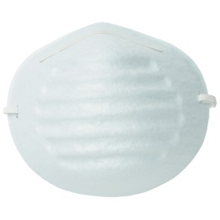
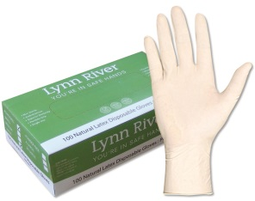 | Wear Gloves |  |  | 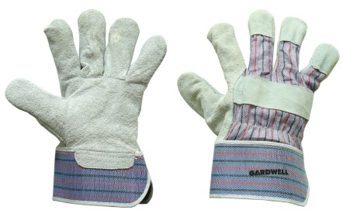
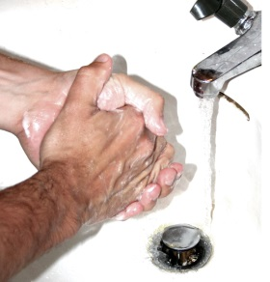 |  |  | Wash Hands Regularly

Silt Contamination

No Heavy Metals within Edgecumbe Township

Bacterial – Faecal (Human/Animal) & Plant materials will break down with:

Sun | + | Rain |  | + | Time | + | Working the soil  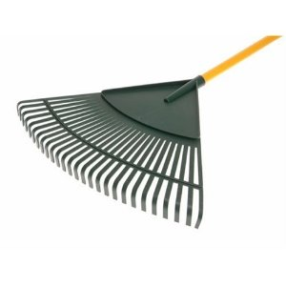
Dependant on the silt depth

