Red Stickered Properties
Assisted Access Entry
Process and Protocols

Contents
1. Red Stickered Property Access Process 4
2. Access Rules 6
3. Personal Protective Equipment (PPE) Required 6
4. Health & Safety 7
4.1. Hazards Register 7
4.2. Specific Property Details 10
12 Rata Avenue 10
16 Rata Ave 11
18 Rata Ave 12
20 Rata Ave 13
46 College Road 14
52 College Road 15
54 College Road 16
56 College Road 17
58 College Road 18
60 College Road 19
62 College Road 20
64 College Road 21
66 College Road 22
68 College Road 23

Red Stickered Property Access Process
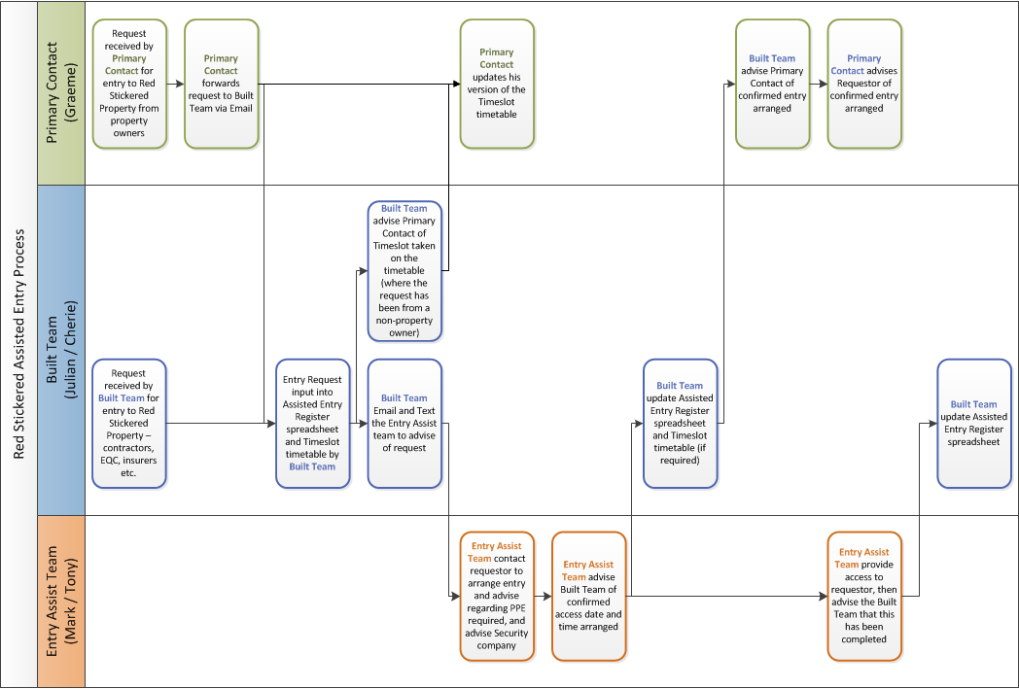
ISCL (Security) require confirmation of approved access before entry allowed

Red Sticker Property Primary Contact
Graeme Bates – The Property Group GBates@propertygroup.co.nz 027 499 9131
Built Team
Julian Reweti – Built Lead Julian.Reweti@whakatane.govt.nz 027 600 7921
Cherie Richardson – Built Assistant Cherie.richardson@boprc.govt.nz 027 288 6928
ISCL – Security – please advise Nigal Thurgood Nigal.Thurgood@iscl.co.nz of entry approvals
Red Sticker Entry Assist Team
The following are authorised to assist with entry for red sticker properties:
Primary Team - The below 2 organise who enters normally – contact both by email and text:
- Mark Cleghorn (WDC) mark.cleghorn@whakatane.govt.nz 027 807 0723
- Tony Gillard (Rural Fire Manager) tony.gillard@whakatane.govt.nz 027 280 9497
Time slots available (2 bookings per time slot – Tony / Mark):
Monday – Friday  8.00 am – 10.00 am  10.00 am – 12 noon  1.00 pm – 3.00 pm  3.00 pm – 5.00 pm | Saturday  10am – 12 noon  1pm - 3pm | Sunday  NOT Available
Backup Team - If Tony or Mark can’t attend then they will try the other two, if we can’t get hold of the above we go direct to the other two.
  - Alan Keeber (Team Leader - Rescue) alan@keebers.com 0274988866
- Neal Yeates (WDC) neal.yeates@whakatane.govt.nz 027 474 2282

Access Rules
- ALL Access to be Assisted – Assisted Entry Team must accompany people onto site
- All Access will be monitored and confirmed entry by ISCL (security)
- ALL Access will be generally limited to 2 hours
- PPE must be worn

Personal Protective Equipment (PPE) Required
- Overalls
- Gloves
- Dust Masks
- Appropriate Footwear (enclosed, sturdy - gumboots)
- Hard Hats (if required – Assisted Entry Team personnel to determine need)

Health & Safety
- Wear appropriate PPE (Gloves, Overalls, Masks, appropriate footwear)
- Avoid touching your face whilst onsite.
- Wash hands frequently and after leaving the property.
- Wash or dispose of PPE and clothing as appropriate following visit.

Hazards Register
Hazard | Risks | Risk Awareness & Control / Mitigation
General
Dead stock/pets | Mental trauma | - Ask for help.  - Talk to those around you to help unload.  - Remove yourself from the situation, or potential.
Wandering stock/pets | Bites | - Contain if safe to do so. Animals will be stressed and hungry so stay clear if aggressive, call SPCA
Water and silt contaminated by human waste, chemicals, other waste, sharp objects | Illness through exposure, cuts | - PPE; gumboots, paper overalls, cut resistant gloves, hygiene, alcohol gel as required.  - Wear protective gear.  - Wash hands, especially before eating.  - Maintain separation between safe and contaminated zones
Slips, trips, holes | Injury | - Good footwear, check terrain, probe ahead if unsure.
Manual handling, tools, fatigue | Sprain or strain, cuts, serious injury | - Work to your limits, seek help, take breaks.  - Use 15kg per person as weight limit guide  - Make sure you know how to use a tool safely.
Other people | Frustration, grief | - Empathy, walk away if feeling threatened.
Machinery, vehicles and contractors working, including on and adjacent to roads | Injury, death, work conflict | - Stay outside machine operating range plus a buffer (e.g. 4m minimum)  - Make eye contact with operator when passing or working in area  - If temporarily walking or driving within bucket range of excavator/grappler/loader (eg to get past machine on roadside), ensure operator has machine stationary and has acknowledged that s/he knows you are there  - Talk to contractor. Establish a safe way of working together if possible. Stay clear if not possible.
Unstable Trees | Serious injury, death | - Avoid walking or working in proximity of trees wherever possible.
Dangerous Houses / Buildings | Serious injury, death | - Avoid entry or working in proximity of houses wherever possible.
Undermining | Serious injury, death | - Check individual property details below (see section 0 below) for specific undermining information.  - Check all structures/walkways etc. before walking on them.
Chemicals - Chemicals may be stored or scattered within and around properties/houses/buildings.  Chemicals may be stored within non-original packaging/containers.  Containers may be damaged and leaking / spilled. | Illness through exposure, cuts, ingestion | - PPE; gumboots, paper overalls, cut resistant gloves, hygiene, alcohol gel as required.  - Wear protective gear.  - Wash hands, especially before eating.
Cabling | Injury (electrocution), trip hazard | - Watch for trip hazards.  - Treat all cabling as live at all times.
Pests – Rat Bait, Rat Bait Stations, carcasses, faeces | Illness through ingestion | - PPE; gumboots, paper overalls, cut resistant gloves, hygiene, alcohol gel as required.  - Wear protective gear.  - Wash hands, especially before eating.
Within Houses/Buildings
Mould | Illness through inhalation | - PPE; gumboots, paper overalls, cut resistant gloves, hygiene, alcohol gel as required.  - Wear protective gear.  - Wash hands, especially before eating.
Dust may contain toxic materials | Illness through inhalation | - PPE; gumboots, paper overalls, cut resistant gloves, hygiene, alcohol gel as required.  - Wear protective gear.  - Wash hands, especially before eating.
Rotting foodstuffs - Rotting food may be present within houses and buildings, attracting vermin, insects and animals. | Illness through ingestion | - PPE; gumboots, paper overalls, cut resistant gloves, hygiene, alcohol gel as required.  - Wear protective gear.  - Wash hands, especially before eating.
Electrical items - may be damaged by water and may still be connected to the power outlets. | Injury (electrocution) | - Treat all electrical items as live at all times.
Unstable fixtures and chattels - Items within buildings and houses may be unsecured, dangerously positioned etc. | Injury | - Check for the secure positioning of items before moving around them.  - Avoid unstable items wherever possible.
Asbestos from building materials including linoleum flooring, textured ceilings and exterior wallboards | Inhalation of particles causing chronic respiratory disease | - DO NOT assist in the removal of lino flooring, textured ceilings or old-style exterior wallboards where asbestos is possible.  - Ensure old carpets and underlays are damp before handling

Specific Property Details

12 Rata Avenue
Inspection Notes / Comments
Extensive ground damage in close proximity to house. North east and south east corners of dwelling require support and repiling. Possible for work to be undertaken in situ.

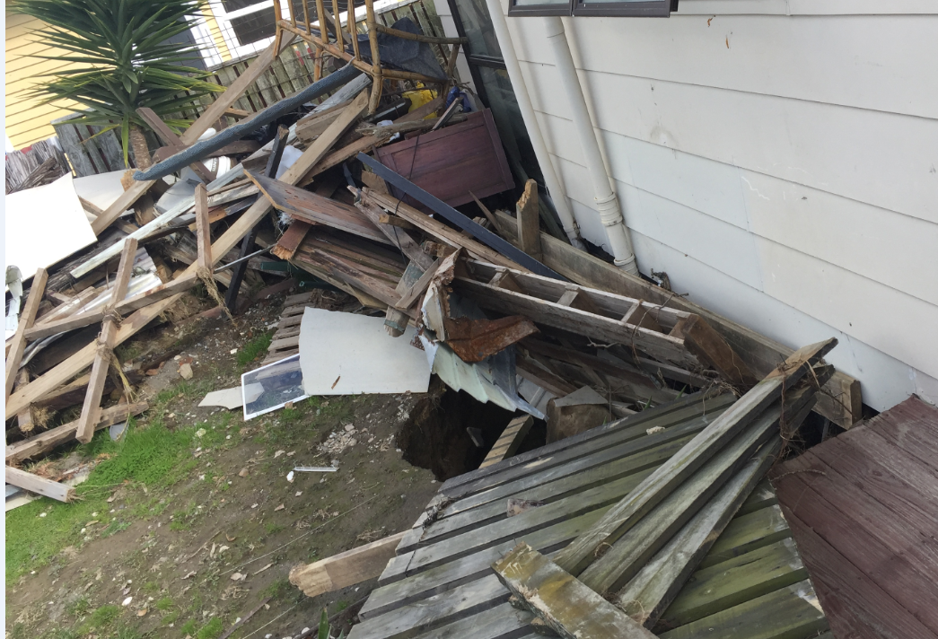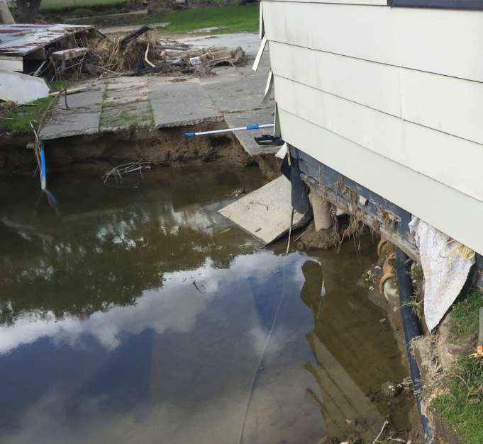

16 Rata Ave
Inspection Notes / Comments
Extensive ground damage south side of house extending under both decks (front and back). Remove house, repair ground, return house to site on new foundations.

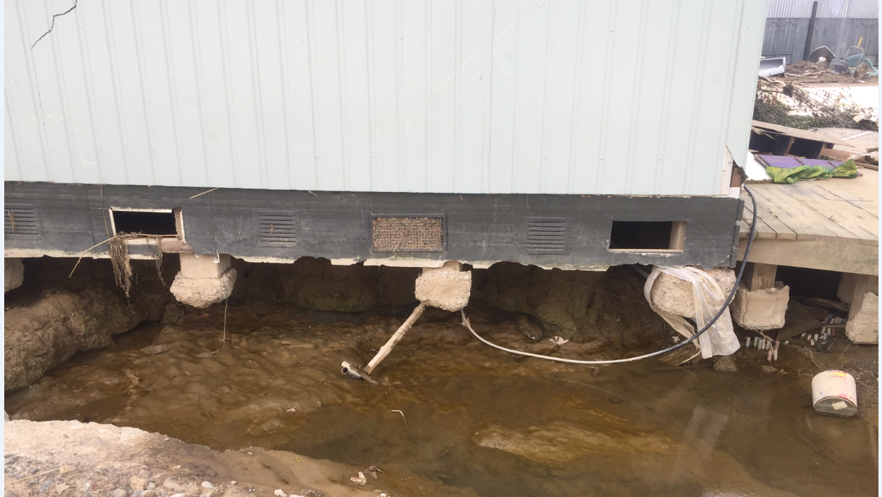

18 Rata Ave
Inspection Notes / Comments
Extensive ground and building damage.

Panels of brick veneer on street side of house in dangerous condition.

Demolish house.

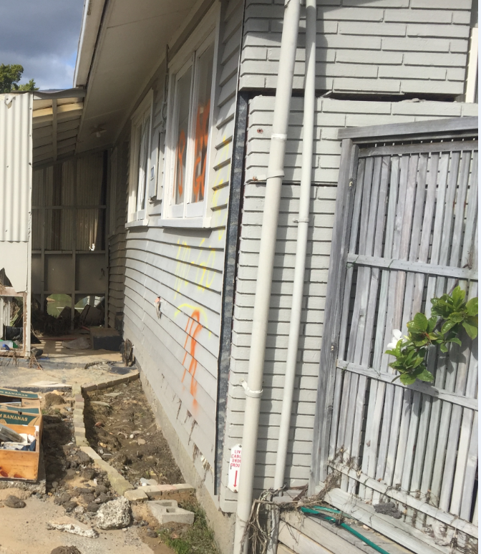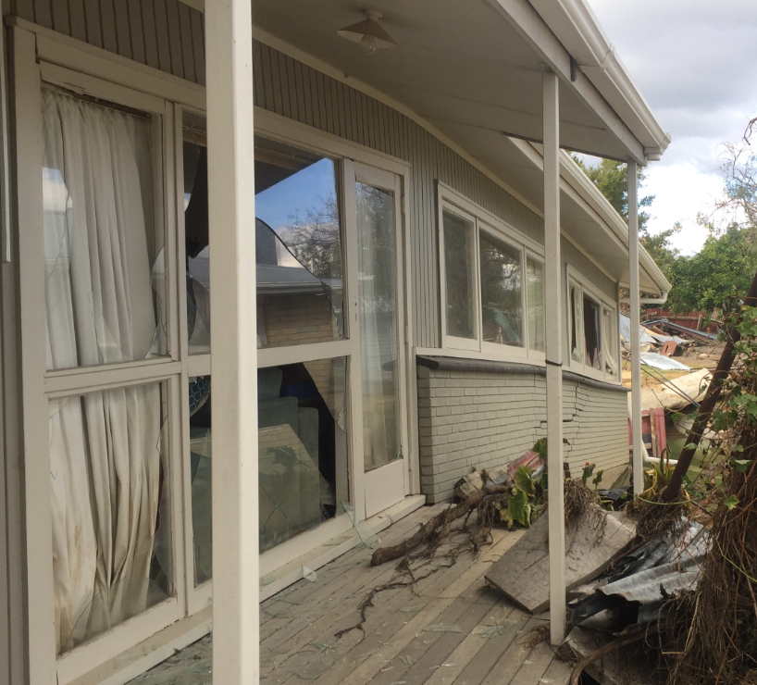

20 Rata Ave
Inspection Notes / Comments
Extensive ground and building damage.

Sections of brick veneer on the south side is held in place by a few wire ties. These sections are dangerous and could fall at any time. Remove bricks under supervision.

Demolish house.

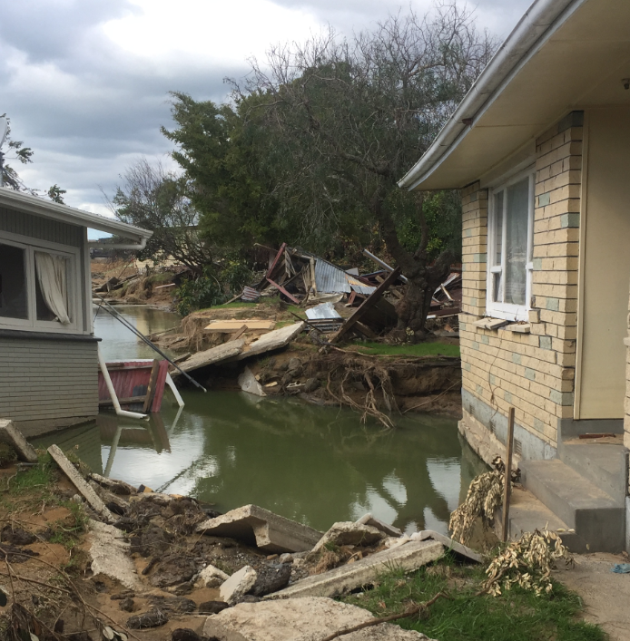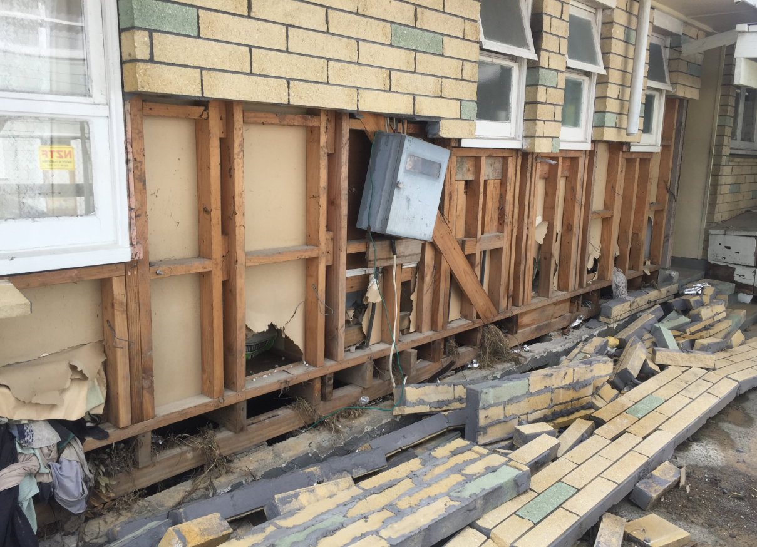

46 College Road
Inspection Notes / Comments
Ground damage east side – front quarter of house piles suspended. Possible for work to be undertaken in situ.

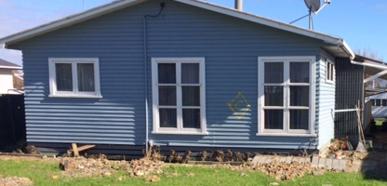

52 College Road
Inspection Notes / Comments
Extensive ground damage with foundation wall settlement. Multiple cracks in brick veneer present safety risk. Remove house, repair ground, return house to site on new foundations

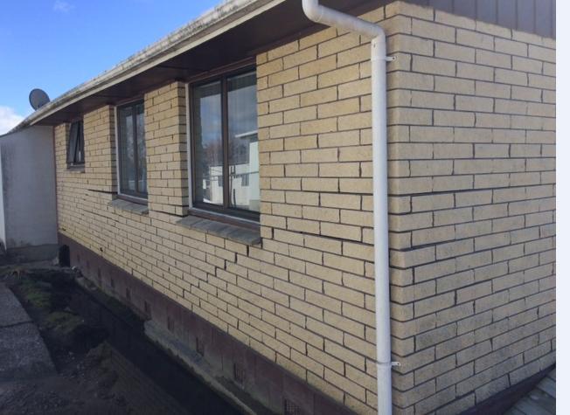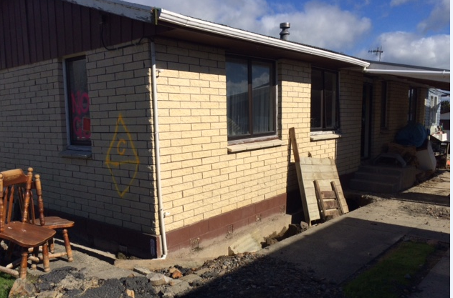

54 College Road
Inspection Notes / Comments
Ground damage south east corner. Repair ground and replace 3-4 piles. Possible for work to be undertaken in situ.

Detached sleepout/garage salvageable.

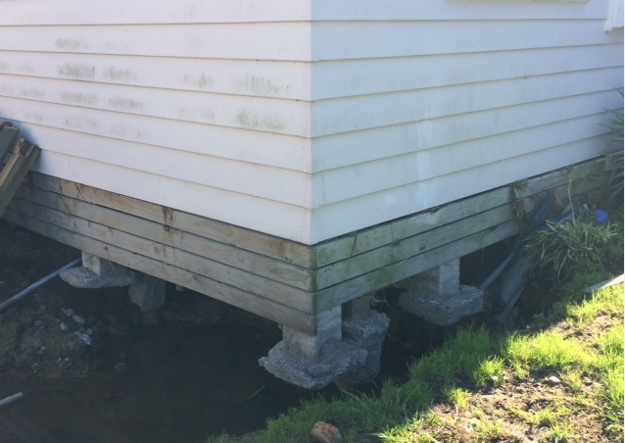

56 College Road
Inspection Notes / Comments
Ground damage south east corner. Repair ground and replace 6 piles. Possible for work to be undertaken in situ.

Detached sleepout/garage and separate garage all salvageable

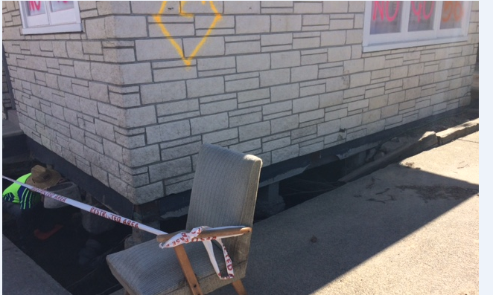

58 College Road
Inspection Notes / Comments
Ground damage south east corner. Repair ground and replace 7 piles. Possible for work to be undertaken in situ.

Detached extended single garage salvageable

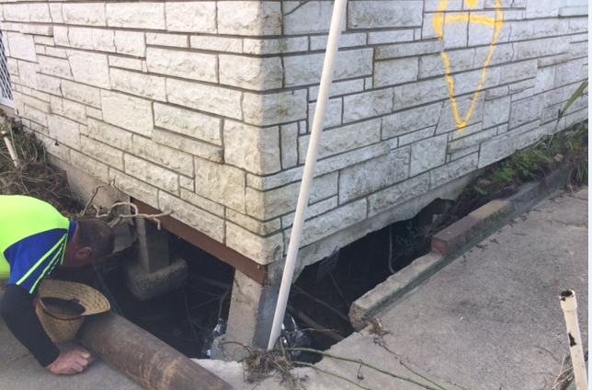

60 College Road
UNSAFE – Do Not Enter

Extensive ground and building damage. Unsafe. Demolition

62 College Road
UNSAFE – Do Not Enter

Extensive ground and building damage. House may be salvageable.

64 College Road
UNSAFE – Do Not Enter

Extensive ground and building damage. Demolition

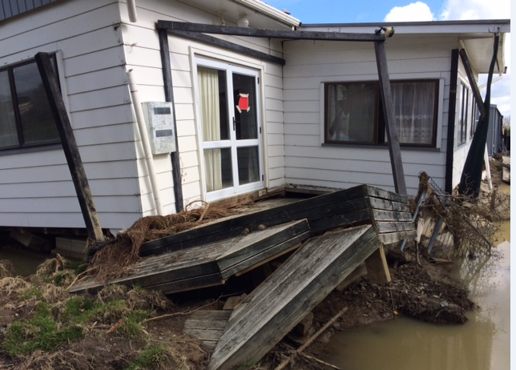

66 College Road
Extensive ground damage. House may be salvageable

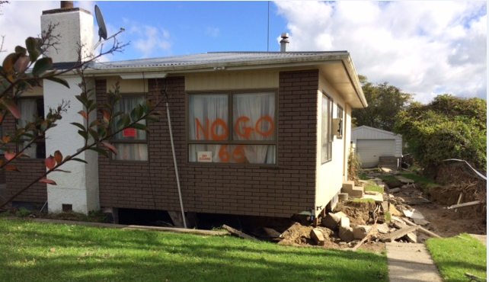

68 College Road
Localised ground damage on east side. Ground repair required prior to repiling. Repairable in situ.

Rear unit has had 300mm of water through building – Yellow placard.

Black Mould is developing within the house.

